Swachhta Pakhwada (15/10/2018 to 31/10/2018)
Essay writing competitions/ painting competitions on ‘Swachh Bharat were held in different government schools across fourteen districts of State of Punjab from 17.10.2018 to 31.10.2018. Besides essay writing competition was also held at GST Bhawan, Rishi Nagar, Ludhiana on 25.10.2018 on the theme ‘Ideas for Swachhta’.
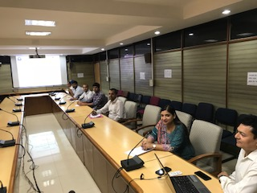
Picture of the Essay Competition held at Hqrs. GST Commissionerate, Ludhiana.

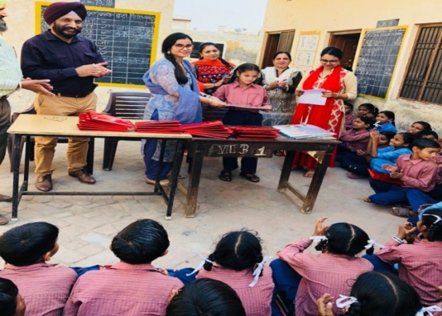
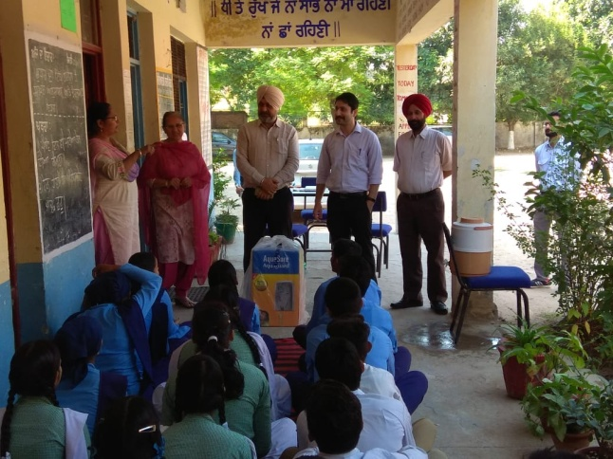
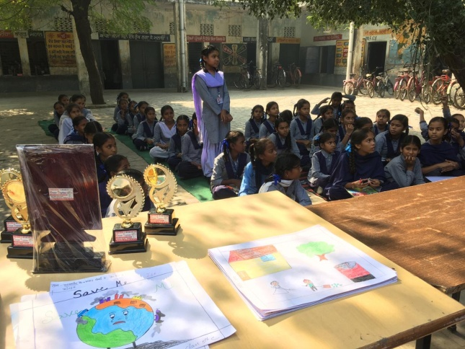
Govt. High School, Phase V, Mohali Govt. School, Jawaddi, Ludhiana-South
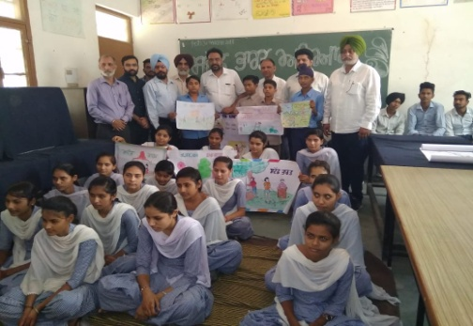

Govt. Primary School, Samana, Patiala Govt.Sr.Sec. School, BhuchoMandi, Bathinda

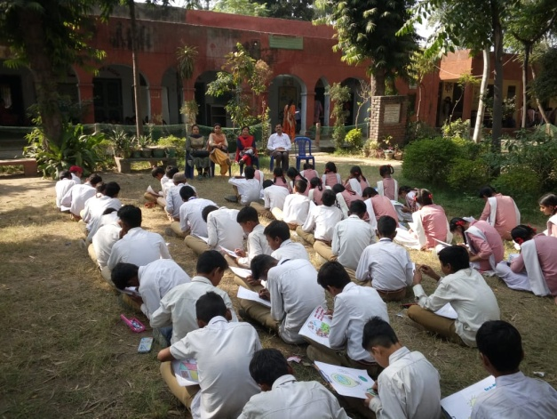
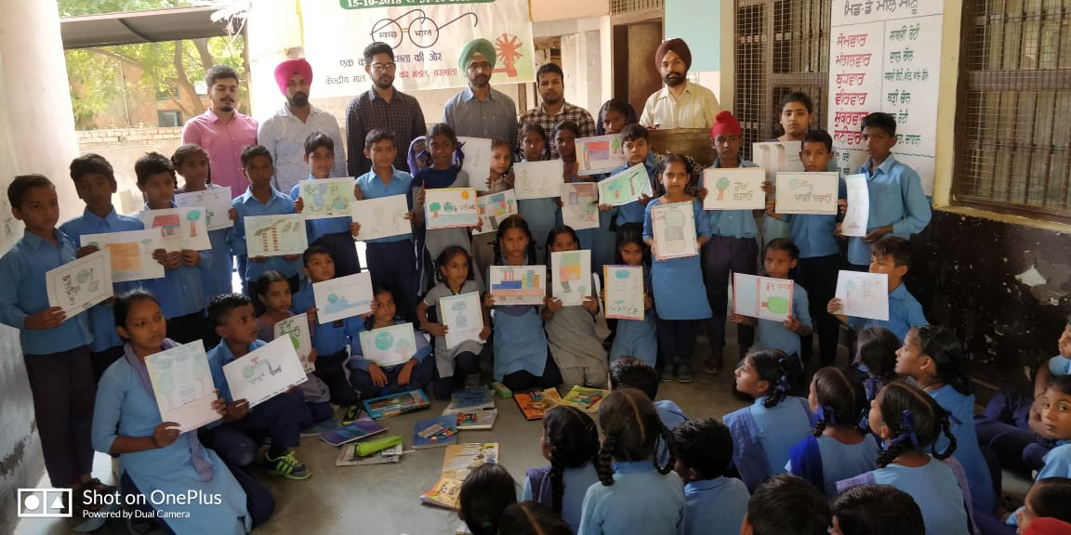
Govt. Primary School, PakhoKalan, Barnala Govt. Sr. Sec. School DhandriKalan, Ludhiana

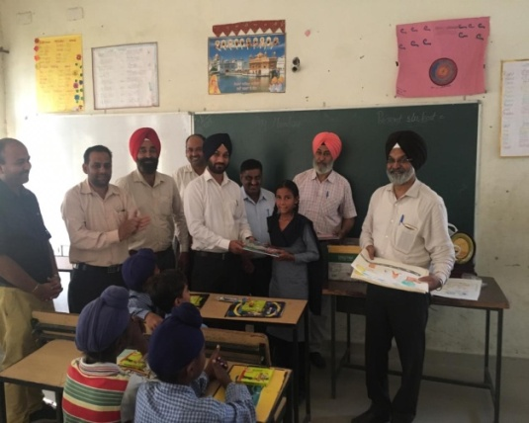
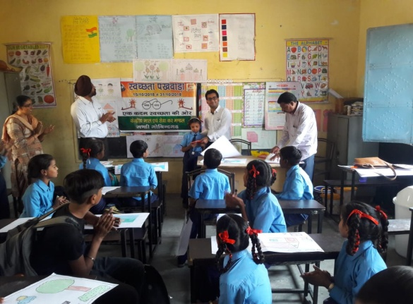

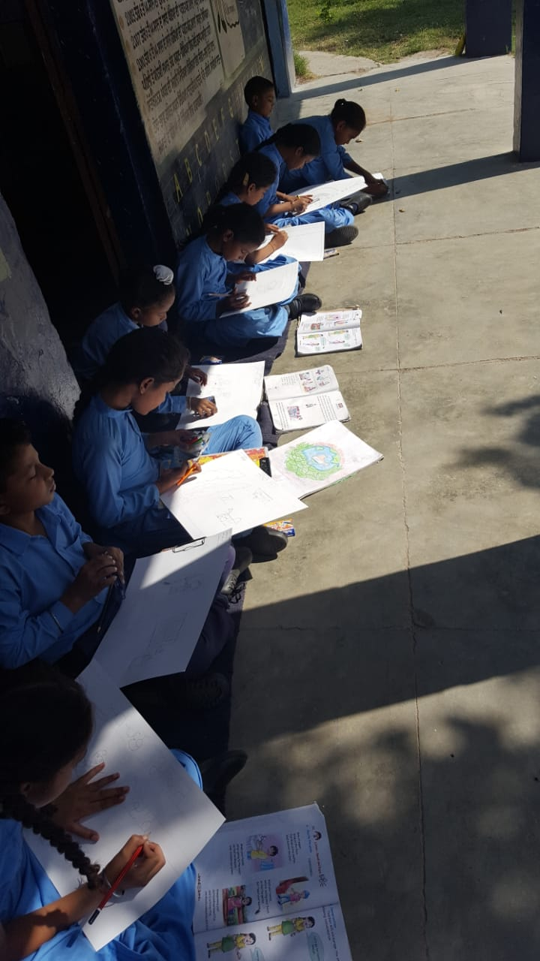
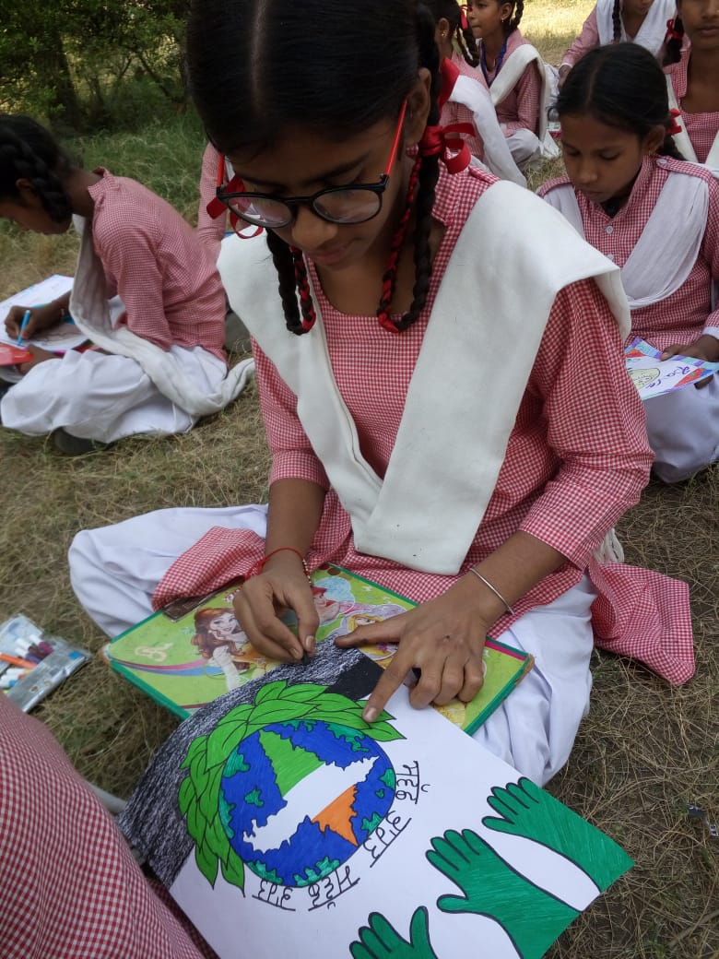
Govt. Elementary School, Prem Nagar, MandiGobindgarh Govt. Primary School, DhiragharaFerozepur

Govt. Sr. Sec. School DhandriKalan, Ludhiana Govt. Elementary School, Ibrahimpur, Derabassi

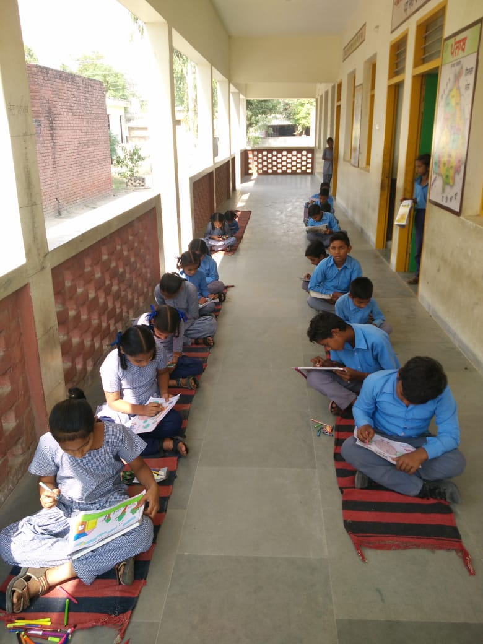
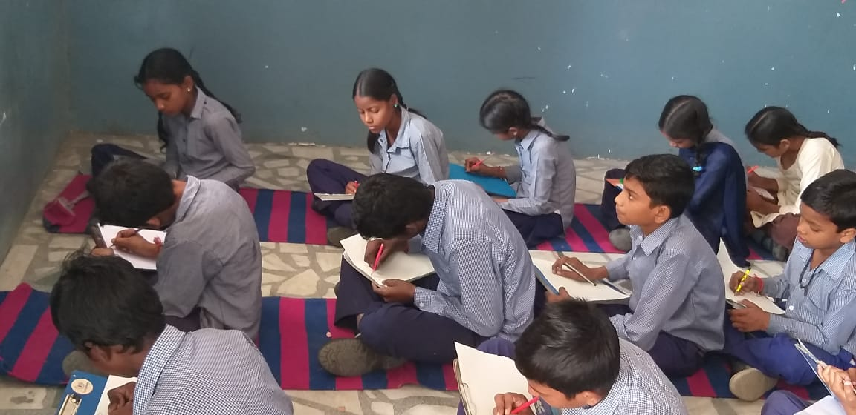
Govt. Elementary School, SekhpurBasti, Sangrur Govt. Middle School, College Road, Ludhiana
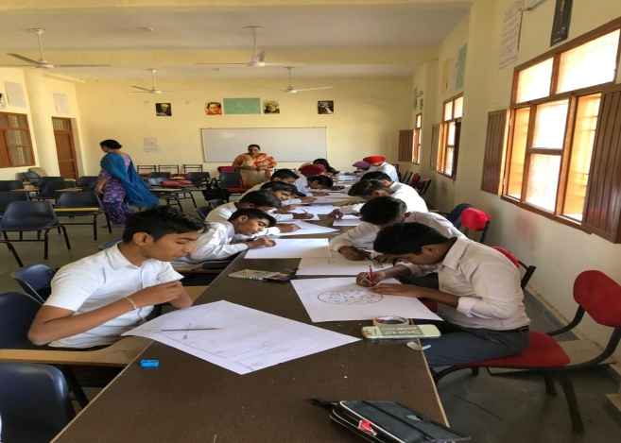
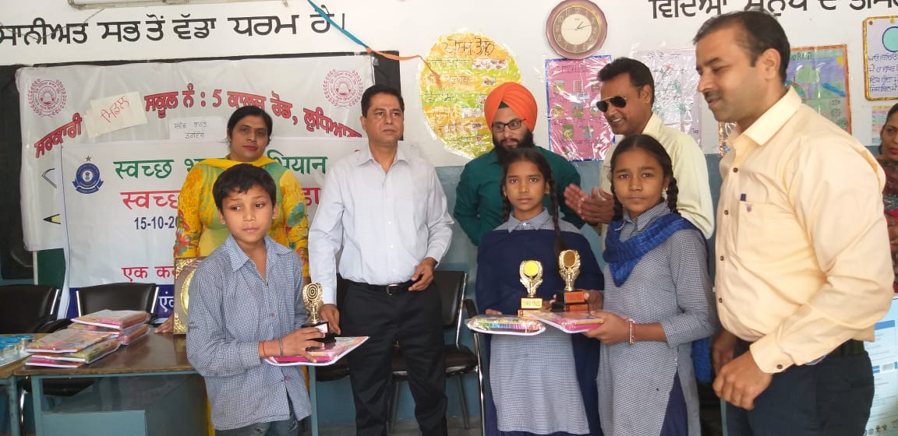

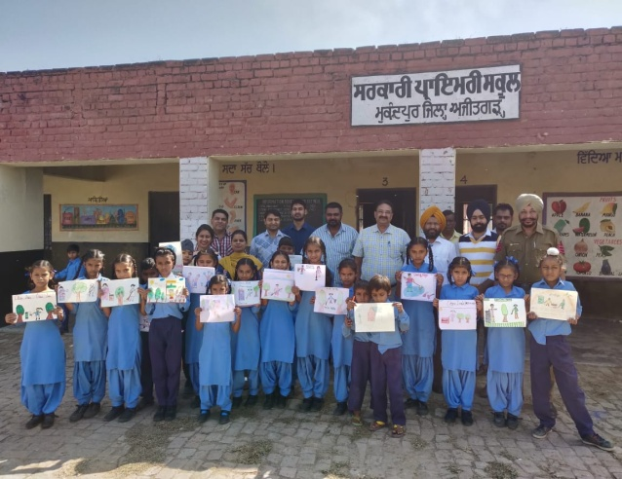
Govt. Middle School No 5, Civil Lines, Ludhiana Govt. Sr. Sec. School, Muktsar Sahib
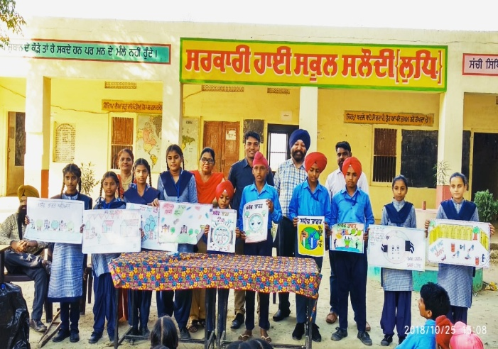
Govt. High School, Salaudi, Khanna Govt. Primary School, Mukundpur, Ajitgarh

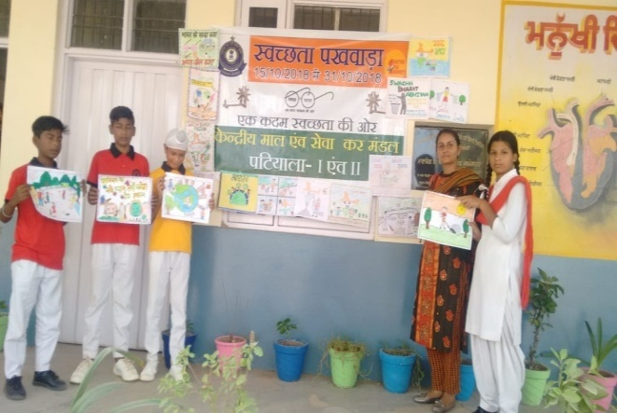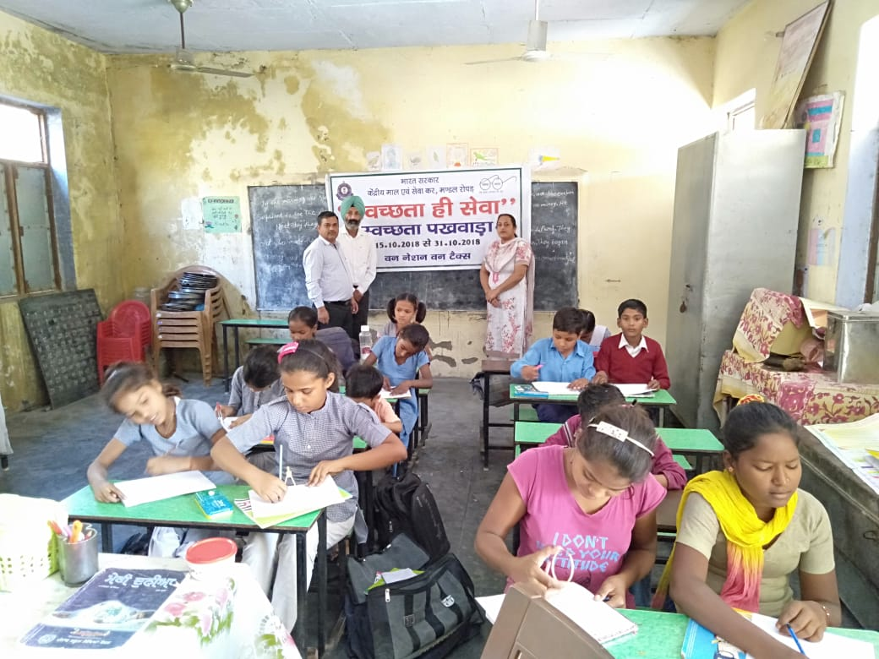
Govt. Sr. Sec. School, Ullana, Patiala Govt.PrimarySchool ,Ropar

Pictures of some of the painting competitions conducted by GST Divisions on the theme “Swachh Bharat” at different schools.

